$$Metrics$$

$$Step-1:Read the data$$

$$Step-2:Preprocess or EDA$$

$$Step-3: Model development \left( ML algorithms Classification\right)$$

$Logistic regression : Linear regression and Sigmiod$

$DT : Entropy and Gini$

$NB :Multiplication , Cp$

$KNN: Euclidian distance$

$$Step-4:Model evaluation$$

$$Step-5:Hyper parameter tuning$$

$$Step-6:Model deployment$$

$$Performance Metrics for classification algorithm:$$

$Confusion matrix$

$Accuracy$

$Error rate$

$True Postive Rate \left( TPR\right)$

$True Negative Rate \left( TNR\right)$

$Sensitivity$

$Specificity$

$Precision$

$Recall$

$F1 score$

$Roc-Auc curve$

$Kohen^{'}s kappa score$

$$Confusion matrix:$$

$$y_{actual} vs y_{prediction}$$

$$assume that origiannly we have two lables y=yes and y=no$$

$$now we are passing an input to the model y_{prediction}=yes or y_{prediction}=No$$

$$How many combination$$

$Actually Yes , model predicted as Yes : True postive$

$Actually Yes , model predicted as No : False Negative$

$Actually No, model predicted as No : True Negative$

$Actually No, Model predicted as Yes : False Positive$

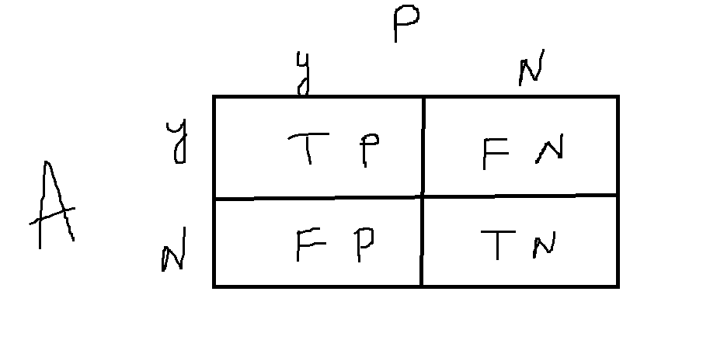

$False Negative : Negative means model says No$

$False means opposite the model , actually yes$

$actualy yes, model predicted as No$

$$False Negative:$$

|  |  |  |  |
| --- | --- | --- | --- |
| $$y_{actual}$$ | $$y_{predicted}$$ | $$Metric$$ | $$label$$ |
| $$Y$$ | $$Y$$ | $$TP$$ | 1 |
| $$y$$ | $$no$$ | $$FN$$ | 0 |
| $$y$$ | $$yes$$ | $$TP$$ | 1 |
| $$no$$ | $$no$$ | $$TN$$ | 1 |
| $$no$$ | $$yes$$ | $$FP$$ | 0 |
| $$no$$ | $$no$$ | $$TN$$ | 1 |

|  |  |  |  |  |
| --- | --- | --- | --- | --- |
| **Classes** | **Yes** | **No** | **Total** | **Recognition** |
| Yes  No | 90  140 | 210  9560 | 300  9700 | TPR=30%  TNR=97% |
| Total | 230 | 9770 | 10,000 | Accuracy=96.5 |

$$accuracy= 96.5\% TPR= 30\% TNR=97\%$$

$$TPR also called as Sensitivity$$

$$TNR also called as Specificity$$

$Confusion matrix$

$Accuracy$

$Error rate$

$TPR: Sensitivity$

$TNR:Specificity$

$Tomorrow is the exam on EDA$

$Churn data set=====office EDA ( before we start ML development classification)$

$Workshop on GEMINIAI (Sunday)$

$Monday will start regression , ML , API , Postman,Streamlit$

$class will start at 7.15am from monday$

$$TPR: \frac{TP}{P}==== > Only postive cases$$

$$TNR=\frac{TN}{N}==== >Only Negative cases$$

$$If a phone number avialable on imgae===Spam : TPR very goood$$

$$Not spam :TNR good$$

$$Originaly yes===Model says yes : TPR$$

$$Originaly yes===Model says no: FN$$

$$TP vs Fn$$

$$Precision and Recall$$

$$Precision= \frac{TP}{TP+FP}$$

$$Recall=\frac{TP}{TP+FN}$$

$$Precision Dr: TP+FP \left(Model predicted postives\right)$$

$$out of model predicted postives how many are matching with original$$

$$Recall Dr: TP+FN \left(Actual postives\right)$$

$$Out of actual postives, how many model predicted correctly$$

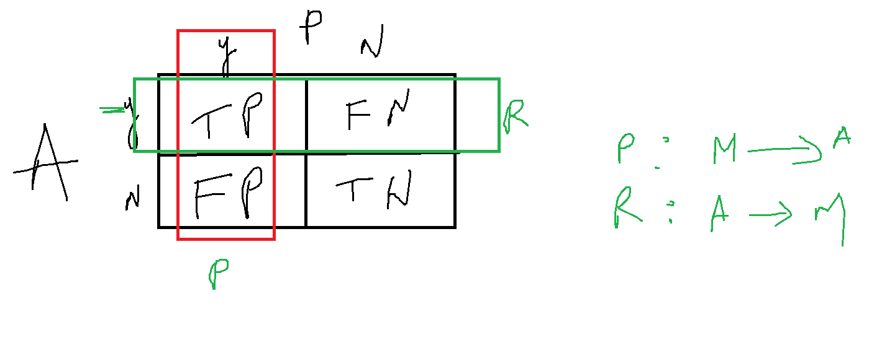

$$Both precision and Recall are talking about TP only$$

$$Precision Dr: FP : Model says yes , but actually No$$

$$Rrcall Dr: FN: Model says No , but actualy yes$$

$$im a terrorist \left(yes\right) ==== No \left(FN\right) (Recall)$$

$$Amabani a terrorist \left(No\right) ==== Yes \left(FP\right) (Precision)$$

$$we want to find the abusive reviews on google maps based on any number or website$$

$$Precision is very bad :$$

$$DT P: 80\% R: 82\%$$

$$LR P: 82\% R: 80\%$$

$$NB P: 81\% R: 83\%$$

$$F1 score:$$

$$Combination of precision and Recall$$

$$AM,GM,HM$$

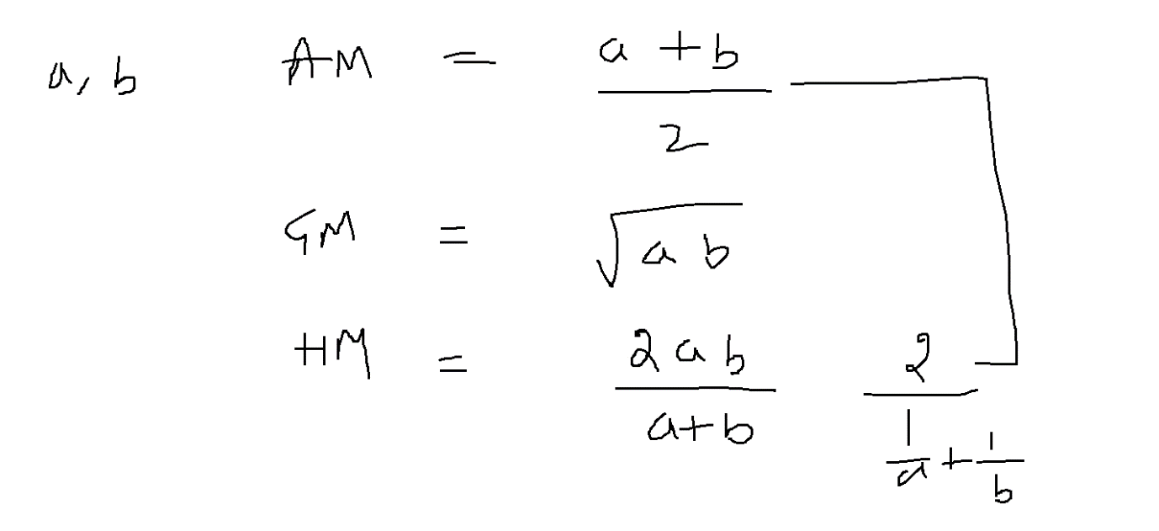

$$F1=\frac{2*Precision*Recall}{Precision+Recall}$$

$$1)Confusion matrix:$$

$TP: actual yes, model says yes$

$FP:actaul no, model says yes$

$FN:actual yes, model says No$

$TN:actal no, model says No$

$$2) Accuracy: \frac{TP+TN}{TP+FP+FN+TN}$$

$$3) Error: 1-Accuracy$$

$$4) TPR: \frac{TP}{P}: sensitivity$$

$$5) TNR: \frac{TN}{N}: specificity$$

$$6) Precicion : \frac{TP}{TP+FP}$$

$$7) Recall: \frac{TP}{TP+FN}= Sensiituvity=\frac{TP}{P} : TP+FN=P (Actual postives)$$

$$8) TPR=Sensitivity=Recall$$

$$9) F1 score: \frac{2*P*R}{P+R}=$$

$$ROC-AUC curve$$

$$Riciever opertaive characterstics$$

$$AUC:Area under the curve$$

$$It is graph between FPR vs TPR$$

$$FPR: False postive Rate=1-specificity=\frac{FP}{N}$$

$$TPR: True postive Rate=Sensitivity=\frac{TP}{P}$$

$$FPR vs TPR or \left(1-specificity\right) vs sensitivity$$

$$FPR : X-axis , TPR =Y-axis$$

$$TP:actual yes model says yes$$

$$FP: actual no model says yes$$

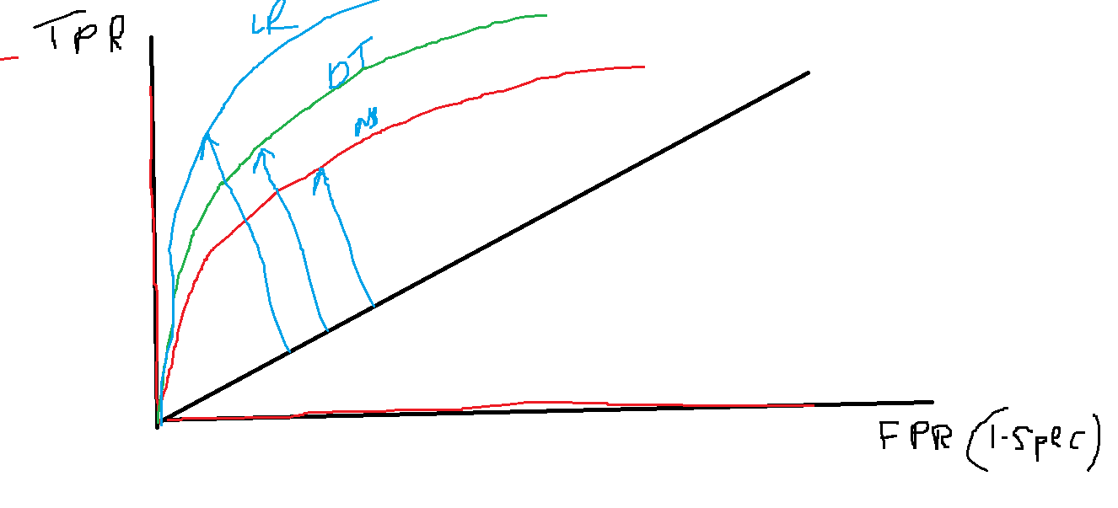

If probability >=0.50 model predicted as Positive, other wise negative

P= 5 N=5

|  |  |  |  |  |  |  |  |  |
| --- | --- | --- | --- | --- | --- | --- | --- | --- |
| **Tuple** | **Y_actual CLASS** | **Prob** | **Y_predction** | **TP** | **FP** | **TP/P** | **FP/N** | **FPR,TPR** |
| 1 | P | 0.90 | P | 1 | 0 | 1/5=0.2 | 0/5=0 | (0,0.2) |
| 2 | P | 0.80 | P | 2 | 0 | 2/5=0.4 | 0/5=0 | (0,0.4) |
| 3 | N | 0.70 | P | 2 | 1 | 2/5=0.4 | 1/5=0.2 | (0.2,0.4) |
| 4 | P | 0.60 | P | 3 | 1 | 3/5=0.6 | 1/5=0.2 | (0.2,0.6) |
| 5 | P | 0.55 | P | 4 | 1 | 4/5=0.8 | 1/5=0.2 | (0.2,0.8) |
| 6 | N | 0.54 | P | 4 | 2 | 4/5=0.8 | 2/5=0.4 | (0.4,0.8) |
| 7 | N | 0.53 | P | 4 | 3 | 4/5=0.8 | 3/5=0.6 | (0.6,0.8) |
| 8 | N | 0.51 | P | 4 | 4 | 4/5=0.8 | 4/5=0.8 | (0.8,0.8) |
| 9 | P | 0.50 | P | 5 | 4 | 5/5=1 | 4/5=0.8 | (0.8,1) |
| 10 | N | 0.40 | N | 5 | 4 | 5/5=1 | 4/5=0.8 | (0.8,1) |

|  |  |  |  |  |
| --- | --- | --- | --- | --- |
| 1 | P | 0.90 | P |  |
| 2 | P | 0.80 | P |  |
| 3 | N | 0.70 | P |  |

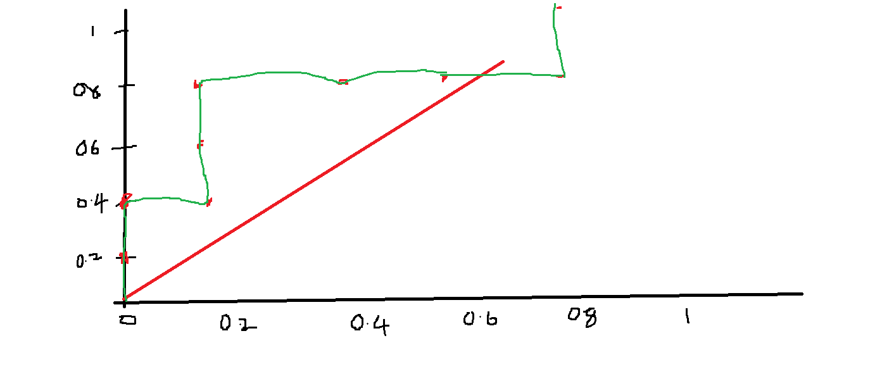

$Cohens kappa model :Assignment$